

Project Report

**Project Title :** BU Bus Stop

**Course Title :** Computer Graphics lab

**Course Code:** CSE-4110

**Submitted To:** Dr. Md Manjur Ahmed

Assistant Professor & Chairman

Department of Computer Science & Engineering,

University of Barishal

**Submitted By:** Hafsa [16CSE-002]

Nadira Aktar [16CSE-017]

Semester - 7th

Department of Computer Science & Engineering,

University of Barishal

**Date of Submission:** 15 Nov, 2021

**Acknowledgement**

First and foremost, praises and thanks to Allah, the Almighty, for His blessings throughout our project to complete it successfully.

We would like to express our deep and sincere gratitude to our graphics lab instructor and honorable chairman, **Dr. Md Manjur Ahmed Sir,** Department of computer science and Engineering, for giving us the opportunity to do our project under his supervision and providing invaluable guidance throughout this project.

His dynamism, vision, sincerity and motivation have deeply inspired us. He has supported us mentally when we faced huge problems about our project topic. He has taught us the methodology to carry out the project.It was a great privilege and honor to work and study under his guidance.

# **Table of Content**

**1.Introduction** **4**

**2.Objective of this project** **4**

**3.Elements/Objects** **4**

**4.Functions** **5**

**5.Controlling Functions** **6**

**6.Features** **7**

**7.Conclusion** **9**

## 

## 

## 

## 

## 

BU Bus Stop

## **1.Introduction**

Going to university and attending classes timely seems sometimes a great hassle for students. For this reason, Barisal university authorities started bus services for their students. Bus comes to several bus stops to take students to the varsity on time.

Here we have developed a project like graphical representation of this system for our graphics lab. The bus comes according to the bus schedule, carries students and transports them. Finally reach them to the university gate timely. We have also implemented a 3D camera view with animation and keyboard control system.

Now we are going to describe how we have done this wonderful and efficient graphical 3D project.

Let’s dive in-

## **2.Objective of this project**

* To develop a 3D university bus movement system
* To study, research and implement graphical tools on our project
* To visualize the university bus movement system

## **3.Elements/Objects**

1. **Bus:** Bus is the main object of our project.This bus belongs to the university of barishal.It carries students from different stations to university campus.
2. **Tree:** Several trees stand along the road side.They are essential as well as increase the beauty of the project.
3. **Road light/lamp:** Road lights are used on the road to provide lights during night. It also **beautifies the roads.**
4. **Student:** Students are another important object of our project. The students of the University of Barisal are usually carried by the bus to the university campus.
5. **Bus stop:** Bus stoppage is the place where the bus stops and the students get in and get down from the bus.
6. **University gate:** University of barisal has a gate where the bus stops so that the students join their class.
7. **University building:** It depicts the university of barisal.
8. **Grass:** Grass beautifies the side of the roads.
9. **Cloud :** Cloud beautifies the sky of the project.
10. **Road:** Road is another important object where the bus goes on.

## **4.Functions**

* glClear ---> clear buffers to preset values
* glBegin, glEnd ---> delimit the vertices of a primitive or a group of like primitives.
* glFlush--->The glFlush function forces execution of OpenGL functions in finite time.
* glMatrixMode ---> specify which matrix is the current matrix.
* GL_PROJECTION: Applies subsequent matrix operations to the projection matrix stack.
* glLoadIdentity --->replace the current matrix with the identity matrix.
* glOrtho ---> multiply the current matrix with an orthographic matrix.
* glutInit---> It is used to initialize the GLUT library.
* glutInitDisplayMode---> sets the initial display mode.
* glutInitWindowPosition and glutInitWindowSize---> set the initial window position and size respectively.
* glutCreateWindow---> creates a top-level window.
* glutDisplayFunc---> sets the display callback for the current window.
* glutMainLoop---> enters the GLUT event processing loop.
* glRasterPos --->specify the raster position for pixel operations.
* glutBitmapCharacter---> renders a bitmap character using OpenGL.
* glcolor3ub--->Sets the current color.
* glPushMatrix ---> push and pop the current matrix stack.
* glutSolidCone and glutWireCone---> render a solid or wireframe cone respectively.
* glPopMatrix---> functions pop the current matrix stack.
* glutSolidTorus and glutWireTorus --->render a solid or wireframe torus (doughnut) respectively.
* glutSolidSphere and glutWireSphere --->render a solid or wireframe sphere respectively.
* gluLookAt ---> creates a viewing matrix derived from an eye point, a reference point indicating the center of the scene, and an UP vector

## **5.Controlling Functions**

* **Mouse control - Windows**

This project contains 3 windows. The project name and the development team introduction is placed at the first window. When you press the left key, the show will start.

* **Keyboard control - Bus & Clouds**

As this project has 3 windows, the 2nd and 3rd one is controlled by the keyboard. When you press the arrow key, the windows will change gradually.

* **Animation - Students**

When the bus came near to the bus stop, the student turned into the bus by animation. They are carried and moved by the bus.

* **Translation - Bus**

The bus moves by translating the tx function. When you press the arrow key, the bus moves towards the university passing through the roads.

Also the clouds are translated by the same function.

* **Camera control system**

The full project is camera controlled by the gluLookAt function. It will create a viewing matrix derived from an eye point, a reference point indicating the center of the scene, and an UP vector.

## **6.Features**

* **Step 1 -** Bus comes on the bus stop: Upon running the project, a graphical interface will pop up with the environment of the bus stop, passengers, students, highways and other surroundings.

A bus comes to the bus stand which is defined as the student bus of University of Barishal. Students were waiting at the bus stand for the bus to come.

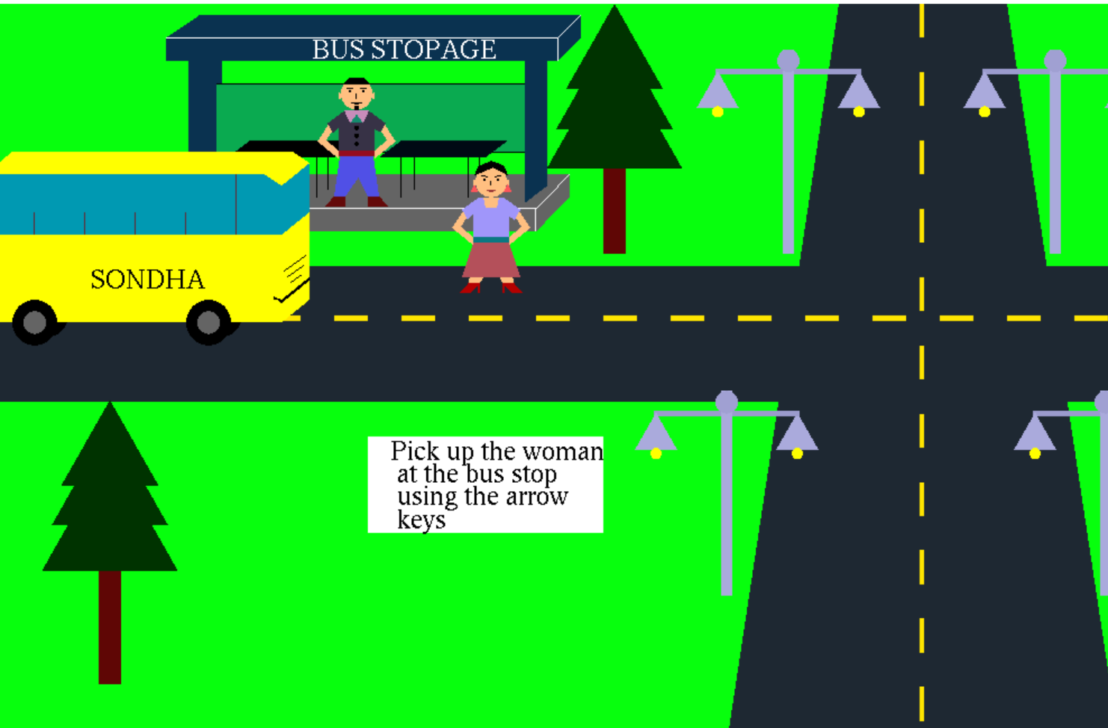

* **Step 2 -** Stand for taking students :The bus will wait for some time to get the students in.
* **Step 3 -** Carry the students into the bus

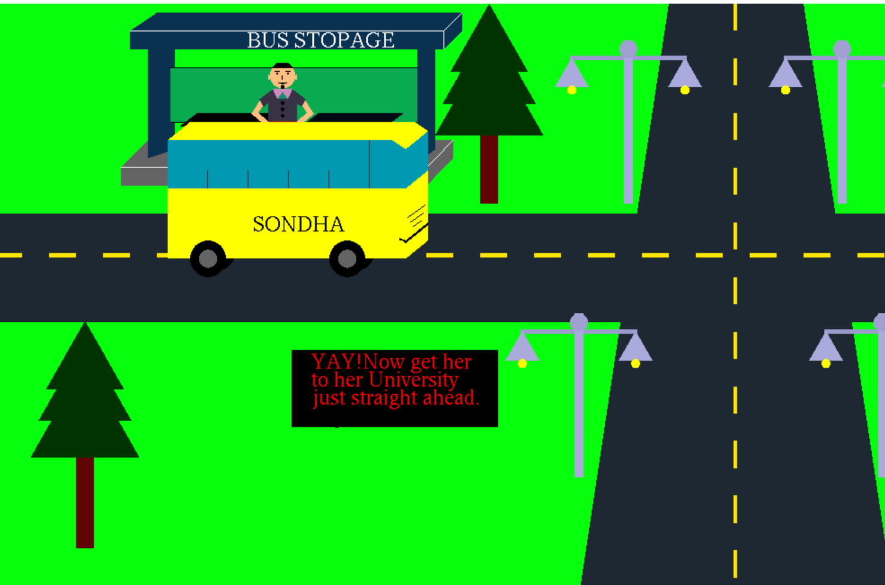

* **Step 4** - Move towards the varsity:Then the bus starts the journey to reach the university campus.

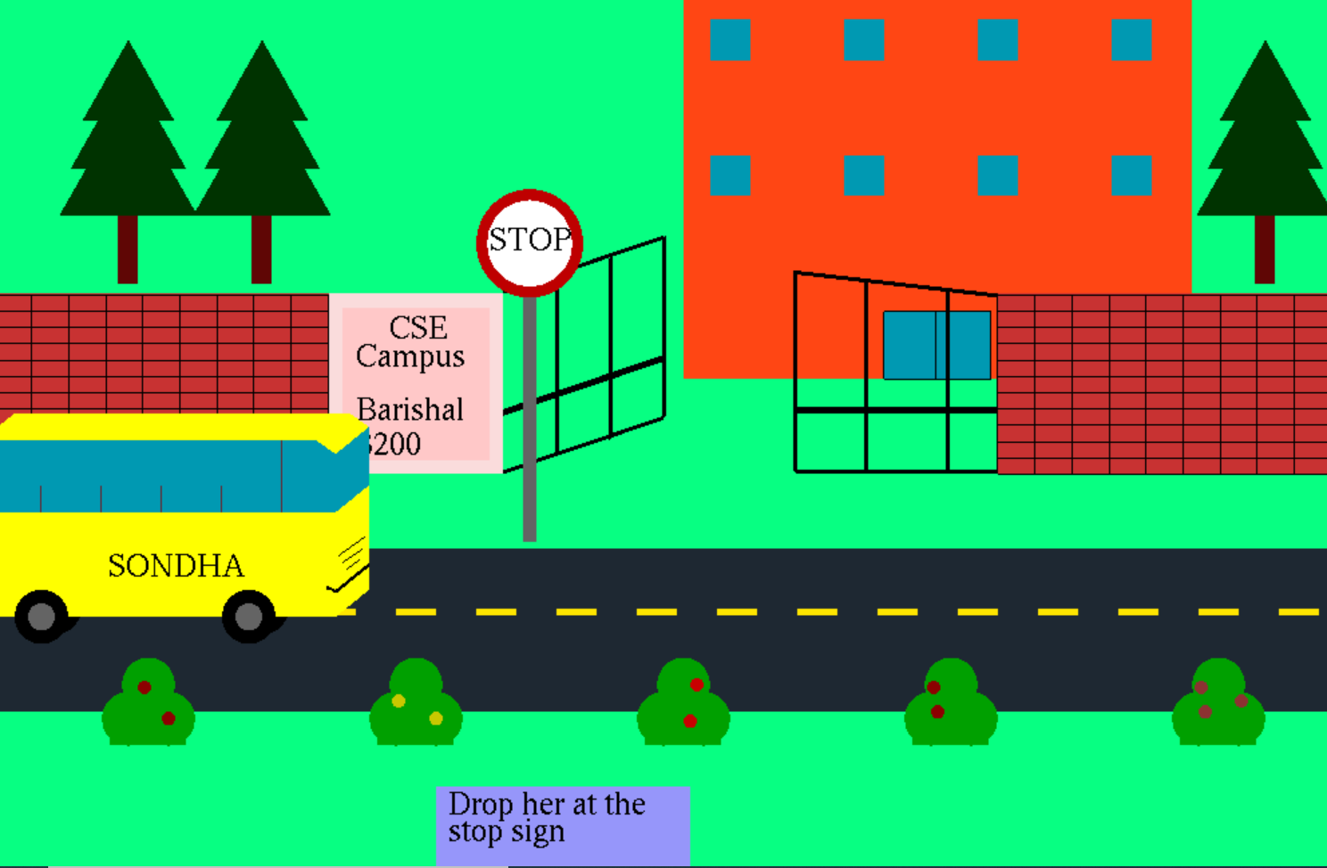

* **Step 5** - Pass several kilometers: The bus continues the journey.
* **Step 6** - Reach to the varsity gate: After some time the bus reaches the university main gate.
* **Step 7 -** Drop the students:Then the bus waits for some minutes so that the students can get down from the bus.

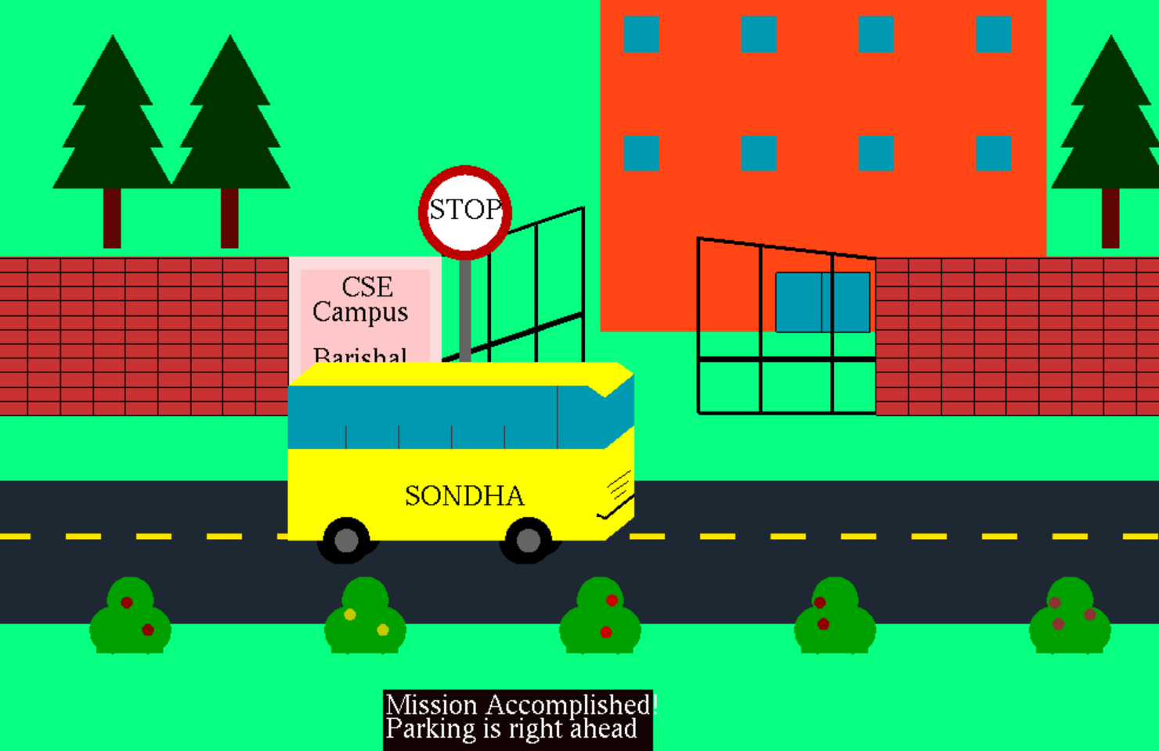

* **Step 8 -** Go :After students get down, then the bus goes to the parking space.

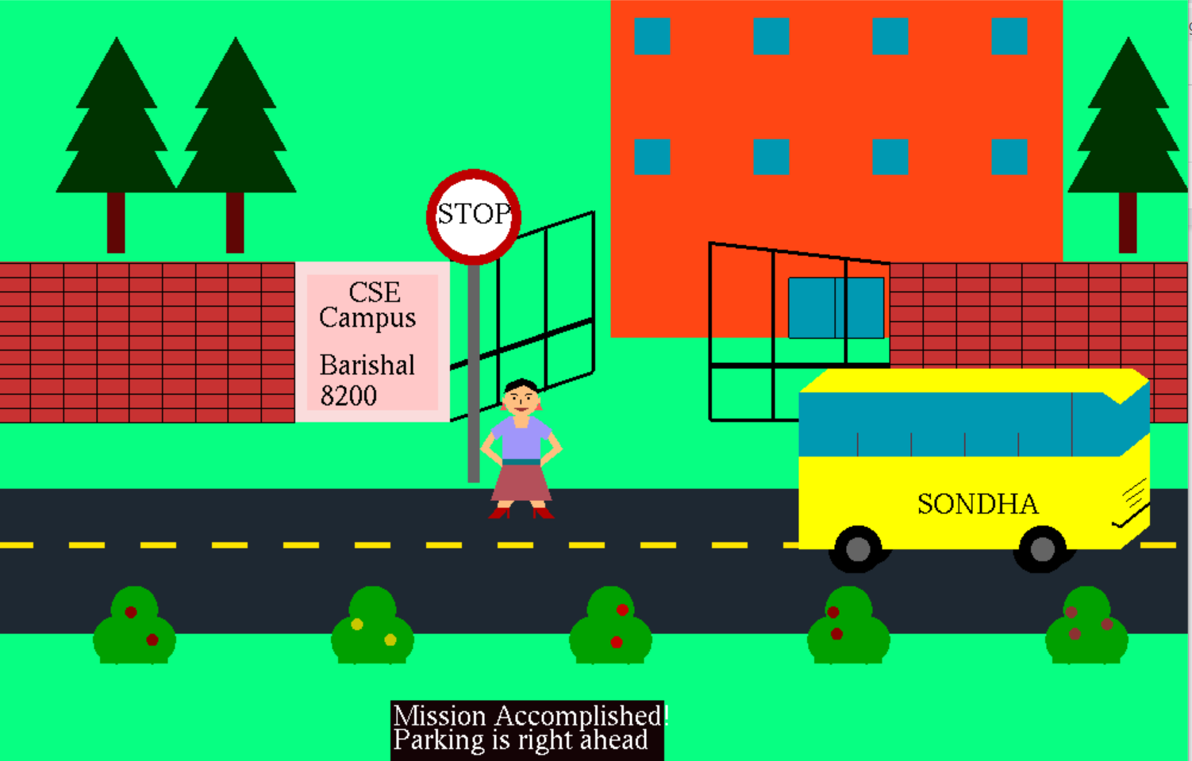

## **7.Conclusion**

Now the time to wrap the content. Here we have done a beautiful 3D project on Barishal University Bus movement system. The graphical representation is performed by several functions. At the same time, the mouse control, keyboard control, object translation, rotation and scaling are done successfully in this project.

Hopefully, this graphical representation will help the students, teachers, and staff to understand the whole bus movement system of the university.